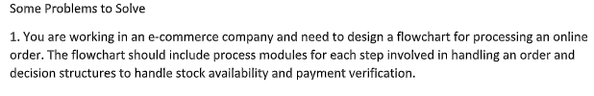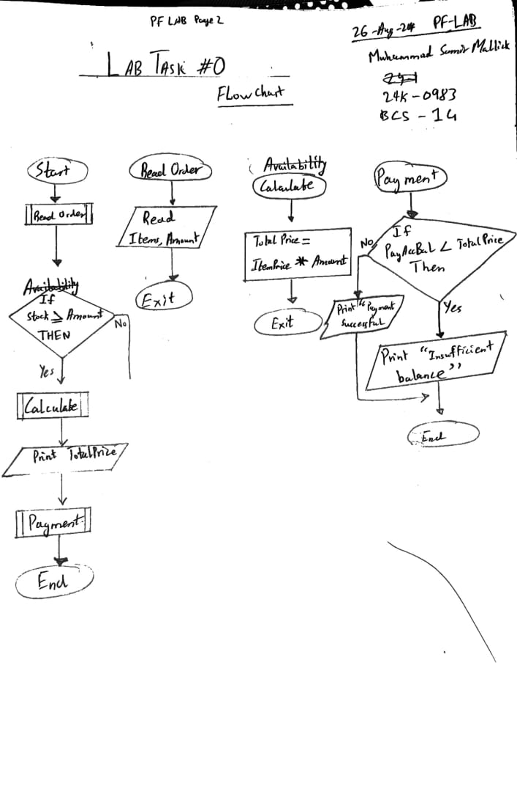

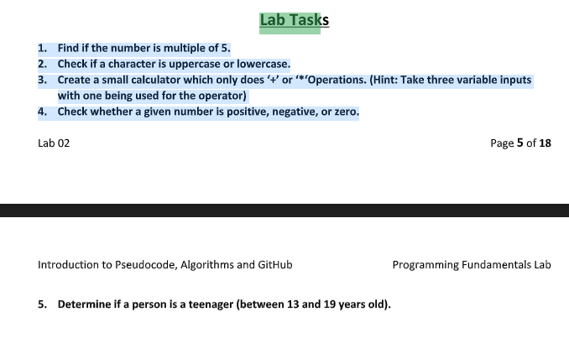Lab Task #1

1. START

INPUT Num1

IF Right(Num1,1) = 5 or Right(Num1,1) = 0 Then

PRINT “The Number is a multiple of 5 “

ELSE

PRINT “The Number is NOT a multiple of 5 “

ENDIF

END

1. START

INPUT Char1

SET Num1 to 0

Num1 = ASCII(Char1)

IF Num1 <91 THEN

Print “The Character is in UpperCase”

ELSE

Print “The Character is in LowerCase”

ENDIF

END

1. START

INPUT Num1

INPUT Num2

INPUT Operator

SET Result to 0

IF Operator = “+” THEN

Result <- Num1 + Num2

ELSE

Result <- Num1 * Num2

ENDIF

PRINT Result

END

1. START

INPUT Num1

IF Num1 >0 THEN

PRINT “The Number is Positive”

ELSEIF Num1 < 0 THEN

PRINT “The Number is Negative”

ELSE

PRINT “The Number is Zero”

ENDIF

END

1. START

PRINT “Enter your age ”

INPUT CheckAge

IF CheckAge < 19 AND CheckAge >13 THEN

PRINT “The person is a teenager”

ELSE

PRINT “The person is NOT a teenager”

ENDIF

END

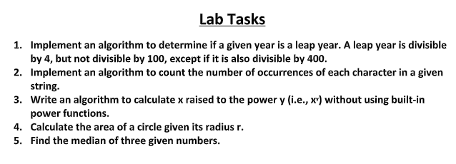

Lab Task # 2

1. Ask the user to enter **Year**

Set **CheckValue** to Right(Year,2) | Set CheckValue to last 2 digit of Year

Set **Flag1** to false

Set **Flag2** to False

Check if Checkvalue divided by 4 is integer, If Yes then

Set flag1 to True

If no then

Set flag1 to False

Check if checkvalue divied by 400 is integer, if yes then

Set Flag2 to True

If no then

Set flag2 to false

Check If Flag1 is true and CheckValue is greater than 0 then

Display “The Year is a Leap Year”

ElseIf Flag1 is true and checkvalue is equal to 0 and flag2 is true then

Display “The Year is a Leap Year”

elseif Flag1 is true and checkvalue is equal to 0 and flag2 is false then

Display “The Year is not a Leap Year”

Else if Flag1 is false then

Display “The Year is not a Leap Year”

2. Ask the user to enter **String**

Set CheckChar to “ “

Set Count to 1

Set CheckChar to Left( String,1)

Then repeat Checking0 other characters of the string by comparing them with character stored in checkchar,

If they are same then add 1 to counter and remove that character

Print the CheckChar and the Count value

Now check if length of string is greater then 0

If yes then repeat from line 2

End

3. Ask the use to enter ValueX

Ask the use to enter ValueY

Set Answer to 0

Check if Y is equal to 1, if yes then

Display ValueX

Else repeat multiplying ValueX with ValueX for (ValueY-1) times, set product to answer

Display Answer

4. Ask the user to enter **Radius**

Set **Area** to (π x Radius^2)

Display **Area**

**5.** Ask the user to enter **Number1, Number2, Number3**

**Version 1:**

Set Median to 0

Check if Number1 is greater than Number2 and Number1 is lesser than Number 3 then

Set median to number1

Else check if Number1 is greater than Number3 and Number1 is lesser than Number 2 then

Set median to number1

Else check if Number2 is greater than Number3 and Number1 is lesser than Number 2 then

Set median to number2

Else check if Number2 is greater than Number1 and Number3 is lesser than Number 2 then

Set median to number2

Else check if Number3 is greater than Number1 and Number2 is lesser than Number 2 then

Set median to number3

Else check if Number3 is greater than Number2 and Number1 is lesser than Number 2 then

Set median to number3

Display Median

**Version 2:**

Set Median to 0

Set Max to 0

Set Min to 0

* If Number1 > Number2 then

Set max to number1

Set min to number2

* Else

Set max to number2

Set min to number1

* If Number3 >Max then

Set Max = Number3

* Else If Number3 <Min Then

Set Min to number3

End if

Set Median to (Number1 +Number2 +Number3)

Set Median to (Median – Max – Min)

Display Median